MACHINE LEARNING
6. Dimensionality Reduction
6.1 Curse of Dimensionality.
6.2 Feature Selection and Feature Extraction.
6.3 Dimensionality Reduction Techniques, Principal Component Analysis.
PAST QUESTIONS:
- What is the curse of Dimensionality? Explain the PCA dimensionality reduction technique in detail. (M23, D23)
- Feature selection methods for dimensionality reduction. (M23)
- Why Dimensionality Reduction is very Important step in Machine Learning? Apply PCA on the following data and find the principle component. (M24)
X | 2 | 1 | 0 | -1
Y | 4 | 3 | 1 | 0.5

NOTES:

*Curse of Dimensionality :-
Curse of Dimensionality refers to a set of problems that arise when working with high-dimensional data. The dimension of a dataset corresponds to the number of attributes/features that exist in a dataset. A dataset with a large number of attributes, generally of the order of a hundred or more, is referred to as high dimensional data.
The Curse of Dimensionality refers to various problems that arise when working with high-dimensional data includes - increased computational complexity, sparsity of data points, and the deterioration of distance-based metrics.
These issues can negatively impact the performance of machine learning algorithms, leading to overfitting, increased generalization error, and decreased interpretability.

*Feature Selection :-
In feature selection techniques, the attributes are tested for their worthiness and then selected or eliminated.

Low Variance filter: The variance in the distribution of all the attributes in a dataset is compared and attributes with very low variance are eliminated.

High Correlation filter: The pair wise correlation between attributes is determined. Pairs that show very high correlation is eliminated and the other retained.

Multicollinearity: In some cases, the high correlation may not be found for pairs of attributes but if each attribute is regressed as a function of others, we may see that variability of some of the attributes are completely captured by the others. This aspect is referred to as multicollinearity and Variance Inflation Factor (VIF) is a popular technique used to detect multicollinearity. Attributes with high VIF values, generally greater than 10, are eliminated.

Feature Ranking: Decision Tree models such as CART can rank the attributes based on their importance or contribution to the predictability of the model. In high dimensional data, some of the lower ranked variables could be eliminated to reduce the dimensions.

*Feature Extraction :-
The Principal Component Analysis is a popular unsupervised learning technique for reducing the dimensionality of data.
It does this by extracting the most informative features from large datasets while preserving the most relevant information from the initial dataset.
It helps to find the most significant features in a dataset and makes the data easy for plotting in 2D and 3D.
Principal component analysis, or PCA, reduces the number of dimensions in large datasets to principal components that retain most of the original information. It does this by transforming potentially correlated variables into a smaller set of variables, called principal components.
The objective of PCA is to select fewer principal components that account for the data's most important variation. PCA can help to streamline data analysis, enhance visualization, and make it simpler to spot trends and relationships between factors by reducing the dimensionality of the dataset.
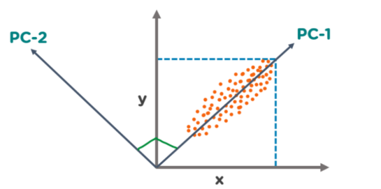
There are two principal components. PC1 is the primary principal component that explains the maximum variance in the data. PC2 is another principal component that is orthogonal to PC1.
The Principal Components are a straight line that captures most of the variance of the data. They have a direction and magnitude.
Steps –
Standardize the Data
- Subtract the mean and divide by the standard deviation for each feature.
- Ensures that each feature contributes equally.
Compute the Covariance Matrix
- The covariance matrix captures the relationships (correlations) between the features.
Calculate Eigenvalues and Eigenvectors
- Find eigenvalues and eigenvectors of the covariance matrix.
- Eigenvectors determine the direction of the new feature space.
- Eigenvalues determine the magnitude (importance) of each direction.
Sort Eigenvectors
- Sort eigenvectors in order of decreasing eigenvalues.
- The top k eigenvectors (with the largest eigenvalues) form the principal components.
Form the Projection Matrix
- Create a matrix WWW using the top k eigenvectors.
- This matrix will be used to transform the data into the new space.
Transform the Data
- Multiply the original standardized data by the projection matrix:
- This gives you the data in the new reduced-dimension space.

